

**SMART WASTE MANAGEMENT SYSTEM**

**FOR METROPOLITIAN CITIES**

**PROJECT REPORT**

**Team ID:**

PNT2022TMID44143

**Team Leader:**

AJMEER KAJA (724019104001)

**Team Members:**

ANSAR M (724019104002)

ARUN VINOD K (724019104003)

NIJAAR AHAMAD (724019104017)

**GUIDED BY:** MOHAMMED NOORDEEN AP/CSE

# ABSTRACT

Timely cleaning of dustbin is a big challenge and if left unaddressed, it may pose several health risks by making the place unhygienic. Current system forthe waste management in local areas of small and highly populated cities is sluggish which leads to a lot of garbage strewn all over the city. The rate of generation of waste is so high that if the garbage collector doesn't visit a place for a couple of days it creates the conditions adverse. In covid-19 pandemic situation, it was very important to monitor and decompose medical waste properly. The handling of normal home garbage was also challenging due to lockdown. In this situation automatic monitoring and controlling of garbage using IOT can play a significance role in garbage management. This paper proposes a smart and fast approach for waste management by creating a network of smart dustbins equipped with sensors and microcontrollers in a city which is monitored by a central control unit to speed up the process in an intelligent and smart way thereby eliminating such hazardous conditions caused by the current sluggish system. The proposed system also takes into account the issue of improper internet connectivity.

i

## TABLE OF CONTENTS

|  |  |  |
| --- | --- | --- |
| **CHAPTER** | **TITLE** | **PAGE** |
|  | **ABSTRACT** | **NO**  **i** |
|  | **LIST OF FIGURES** | **ii** |
|  | **LIST OF TABLES** | **iii** |
|  | **LIST OF ABBREVIATIONS** | **iv** |
| **1.** | **INTRODUCTION** | **1** |
|  | 1.1 PROJECT OVERVIEW | 1 |
|  | 1.2 PURPOSE | 2 |
| **2.** | **LITERATURE SURVEY** | **3** |
|  | 2.1 EXISTING PROBLEM | 3 |
|  | 2.2 REFERENCES | 4 |
|  | 2.3 PROBLEM STATEMENT DEFINITION | 5 |
| **3.** | **IDEATION & PROPOSED SOLUTION** | **6** |
|  | 3.1 EMPATHY MAP CANVAS | 6 |
|  | 3.2 IDEATION & BRAINSTORMING | 7 |
|  | 3.3 PROPOSED SOLUTION | 11 |
|  | 3.4 PROBLEM SOLUTION FIT | 12 |
| **4.** | **REQUIREMENT ANALYSIS** | **13** |
|  | 4.1 FUNCTIONAL REQUIREMENTS | 13 |
|  | 4.2 NON-FUNCTIONAL REQUIREMENTS | 13 |
| **5.** | **PROJECT DESIGN** | **15** |
|  | 5.1 DATA FLOW DIAGRAM | 15 |
|  | 5.2 SOLUTION & TECHNICAL | 16 |
|  | ARCHITECTURE |  |
|  | 5.3 USER STORIES | 18 |
| **6.** | **PROJECT PLANNING & SCHEDULING** | **20** |

* 1. SPRINT PLANNING & ESTIMATION 20
  2. SPRINT DELIVERY SCHEDULE 20
  3. REPORTS FROM JIRA 21

1. CODING& SOLUTIONING 22
   1. FEATURE 1 22
   2. FEATURE 2 24
   3. DATABASE SCHEMA 29
2. TESTING 31
   1. TEST CASES 31
   2. USER ACCEPTANCE TESTING 31
3. RESULTS 32
   1. PERFORMANCE METRICS 32
4. ADVANTAGES & DISADVANTAGES 33
5. CONCLUSION 34
6. FUTURE SCOPE 35
7. APPENDIX 36

SOURCE CODE 36

GITHUB & PROJECT DEMO LINK 46

**LIST OF FIGURES**

## FIGURE NO

**TITLE PAGE NO.**

3.1.1 EMPATHY MAP 6

* + 1. PROBLEM STATEMENT 8
    2. BRAINSTORM 8
    3. GROUP IDEAS 9
    4. PRIORITIZE 10

3.4.1 PROBLEM SOLUTION FIT 12

5.1.1 DATA FLOW DIAGRAM 15

5.2.1 SOLUTION & TECHNICAL ARCHITECTURE 16

6.3.1 REPORTS FROM JIRA 21

7.1.1.1 USER MODULE 22

7.2.1.1 SENSING MODULE 24

* + 1. CLOUDANT DB 29
    2. DB CREATION 29
    3. SMART WASTE MANAGEMENT DB 30

## LIST OF TABLES

**TABLE NO.**

## TITLE PAGE

**NO.**

3.3.1 PROPOSED SOLUTION 11

4.1.1 FUNCTIONAL REQUIREMENTS 13

4.2.1 NON-FUNCTIONAL REQUIREMENTS 14

* + 1. SOLUTION ARCHITECTURE 17
    2. TECHNICAL ARCHITECTURE 18

5.3.1 USER STORIES 19

6.1.1 SPRINT PLANNING & ESTIMATION 20

6.2.1 SPRINT DELIVERY SCHEDULING 20

9.1.1 PERFORMANCE METRICS 32

## LIST OF ABBREVIATIONS

|  |  |
| --- | --- |
| IoT | INTERNET OF THINGS |
| I-SMAC | IoT IN SOCIAL, MOBILE, ANALYTICS AND CLOUD |
| GPS | GLOBAL POSITIONING SYSTEM |
| FR | FUNCTIONAL REQUIREMENTS |
| NFR | NON-FUNCTIONAL REQUIREMENTS |
| DFD | DATA FLOW DIAGRAM |
| MQTT | MQ TELEMETRY TRANSPORT |
| SQL | STRUCTURED QUERY LANGUAGES |
| STT | SECURITY TRANSACTIONS TAX |
| DB | DATABASE |
| RFID | RADIO FREQUENCY IDENTIFICATION |
| UAT | USER ACCEPTANCE TESTING |
| WIFI | WIRELESS FIDELITY |
| OTP | ONE TIME PASSWORD |
| MYSQL | MY STRUCTURED QUERY LANGUAGE |
| NOSQL | NOT ONLY STRUCTURED QUERY LANGUAGE |

**CHAPTER 1 INTRODUCTION**

## PROJECT OVERVIEW

The Internet of Things (IoT) is a concept in which surrounding objects are connected through wired and wireless networks without user intervention. In the field of IoT, the objects communicate and exchange information to provide advanced intelligent services for users.

Project deals with the problem of waste management in smart cities, where the garbage collection system is not optimized. Project enables the organizations to meet their needs of smart garbage management systems. This system allows the user to know the fill level of each garbage bin in a localityor city at all times, to give a cost-effective and time-saving route to the truck drivers.

The rate at which solid wastes are produced in most developing countries is becoming alarming. There are two categories of Urban waste namely, organic and inorganic. The organic waste category can be further categorized into three units: nonfermentable, fermentable and putrescible . The Putrescible wastes tend to decay faster, and if not cautiously managed, decomposition can lead to an offensive odour with an unpleasant view.

Fermentable waste which also tends to decompose rapidly do so without the accompanying of offensive odour. Non-fermentable waste most times do not decompose or do so at a very slow rate. Unless organic waste is managed appropriately, the stricken negative effect it has will continue until full decomposition or stabilization will be occurs. Decomposed products which are poor managed or uncontrolled can and often times lead to the problems such as contamination of air, water and soil resource.

## PURPOSE

Waste management is intended to reduce adverse effects of waste on human health, the environment, planetary resources and aesthetics. The aim of waste management is to reduce the dangerous effects of such waste on the environment and human health. Waste management is an important element of environmental protection. Its purpose is to provide hygienic, efficient and economic solid waste storage, collection, transportation and treatment or disposal of waste without polluting the atmosphere, soil or water system.

Waste management is needed to prevent pollution. Sewage treatment is also a kind of waste water treatment where wastes are removed from water.It helps us to separate bio degradable(eg-paper) and non-degradable wastes(Eg-plastics)

Keeping cities clean is essential for keeping their resident healthy depends not just on personal hygiene and nutrition but critically also on how clean we keep our cities and their surroundings the spread of dengue and chicken gunya are intimately linked to the deteriorating state of public health condition in our cities.

The good news is that waste management to keep cities clean is now getting attention through the swatch Bharat mission how where, much of the attention began in and stops with the brooms and the dustbins, extending at most to the collection and transportation of the mixed waste to some distant or not so distant place preferably out of sight.

Waste management involves the regular collection, transportation as well as processing and disposal or recycling and monitoring of different types of waste materials.

## CHAPTER 2 LITERATURE SURVEY

* 1. **EXISTING PROBLEM**

M. Bhuvaneswari et a1. Waste segregation and disposal mechanisms are among the severe problems associated with smart cities, which have a negative impact on our society and health.

K N Fallavi et a1. As the population is growing, the garbage is also increasing. This huge unmanaged accumulation of garbage is polluting the environment, spoiling the beauty of the area and also leading to the health hazard. In this era ofInternet, IOT (Internet of Things) can be used effectively to manage this solid waste.

M.Selvi et a1. The sensed data by the smart objects are transmitted to the sink for further processing using multi hop communication. The smart cities use the analyzed data to improve their infrastructure, public utilities and they enhance their services by using the IoT technology for the betterment of livelihood of the common people. For IoT based smart cities, waste collection is a prominent issue for municipalities that aim to achieve a clean environment.

Mahmoud Ali Ahmed et a1. Three factors make it a big challenge, behind its natural, small area, short period of time and the increasing of the Pilgrimages' member. The process of collected wastes, separated it, and transports the containers daily and quickly to avoid any prospect of a spread of diseases is a complex process.

Proposed smart systems for waste management system with recycling .The proposed system will use the sensors technique insite the container, as a lower level, to separate the waste into 4 categories [food, plastics, papers, and metal] and use actuator at a top level to inform the management system to collect the container.

## REFERENCES

* + 1. M. Bhuvaneswari; K. Tansin; S. Tazmeel Ahamed; N.Tharun Sri Ram; S. Venu Prasath 2022 7th International Conference on Communication and Electronics Systems (ICCES) Internet of Things based Intelligent Waste Segregation and ManagementSystem for Smart Home Application
    2. K N Fallavi; V Ravi Kumar; B M Chaithra 2017 International Conference on I-SMAC (IoT in Social, Mobile, Analytics and Cloud) (I- SMAC) Smart waste management using Internet of Things: A survey
    3. Jacob John, Mariam Sunil Varkey, Riya Sanjay Podder, Nilavrah Sensarma,

M. Selvi, 19 August 2021 Smart Prediction and Monitoring of Waste Disposal System Using IoTand Cloud for IoT Based Smart Cities

* + 1. Rasha Elhassan; Mahmoud Ali Ahmed; Randa AbdAlhalem 2019 4th MEC International Conference on Big Data and Smart City (ICBDSC) Smart Waste Management System for Crowded area : Makkah and HolySites as a Model
    2. Inna Sosunova and Jari Porras 18 May 2022, accepted 17 June 2022, date of publication 4 July 2022, date of current version 18 July 2022 IoT-Enabled Smart Waste Management Systems for Smart Cities: A Systematic Review

## PROBLEM STATEMENT DEFINITION

The current process of waste management starts with the waste being created by people in the cities and disposed in trash bins near its creation point. The disposed trash is collected by municipality or private company trucks at the predefined times and transferred to temporary collection centers. The trash at the collection centers is then sent for recycling.

This process in current city setting solves the waste problem partially while itcreates other problems such as

* Some trash bins are overfilled while others are underfilled by the trash collection time,
* Overfilled trash bins create unhygienic conditions,
* Unoptimized truck routes result in excessive fuel usage and environmental pollution and
* All collected trash is combined which complicates sorting at the recycling facility.

## CHAPTER 3

**IDEATION & PROPOSED SOLUTION 3.1EMPATHY MAP CANVAS**

An empathy map is a simple, easy-to-digest visual that captures knowledge about a user’s behaviors and attitudes.

It is a useful tool to helps teams better understand their users.Creating an effective solution requires understanding the true problem and the person who is experiencing it. The exercise of creating the map helps participants consider things from the user’s perspective along with his or her goals andchallenges.

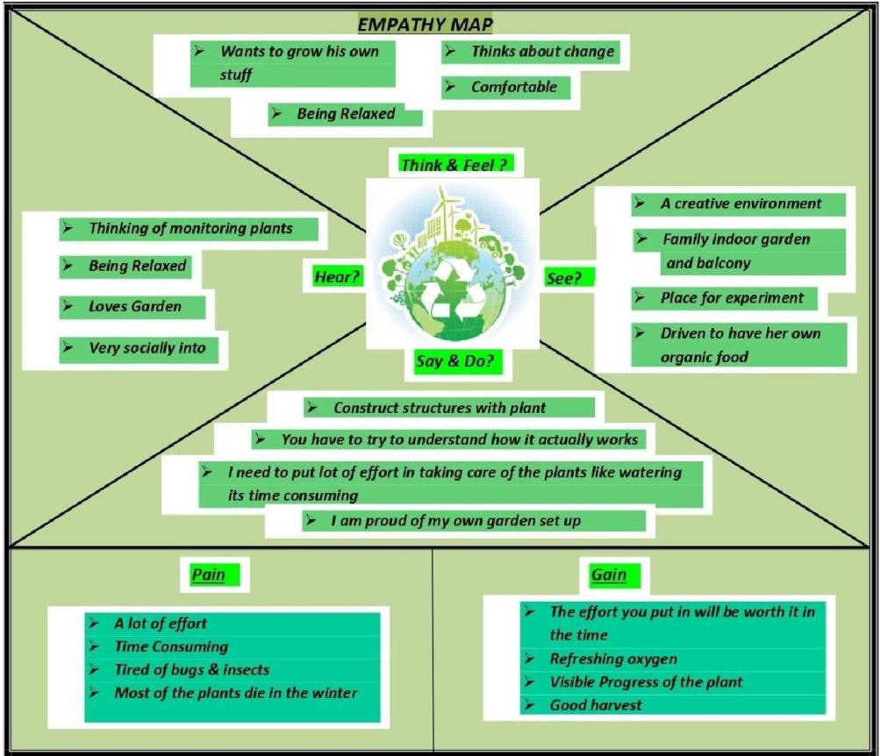

Fig 3.1.1 Empathy Map

## IDEATION & BRAINSTORMING Brainstorm & idea prioritization

Use this template in your own brainstorming sessions so your team can unleash

their imagination and start shaping concepts even if you're not sitting in the same room.

**Before you collaborate**

A little bit of preparation goes a long way with this session. Here’s what you need to do to get going

A .Team gathering

Define who should participate in the session and send an invite. Share relevant information or pre-work ahead.

B. Set the goal

Think about the problem you'll be focusing on solving in the brainstorming session.

C. Learn how to use the facilitation tools

Use the Facilitation Superpowers to run a happy andproductive session.

## Define your problem statement

What problem are you trying to solve? Frame your problem as a How Might We statement. This will be the focus of your brainstorm

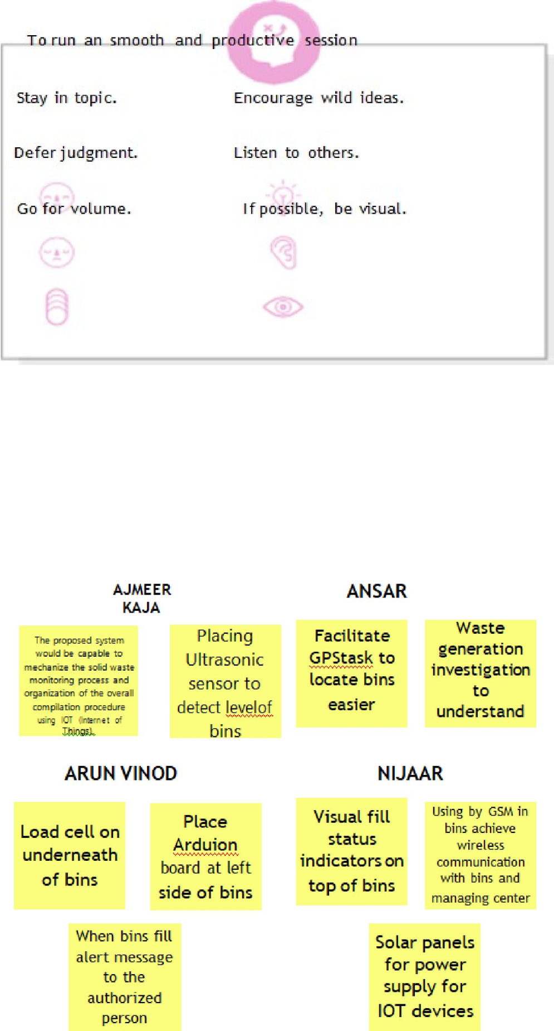

Fig 3.2.1 Problem Statement

## Brainstorm

Write down any ideas that come to mind that address your problem statement.

Fig 3.2.2 Brainstorming

## Group ideas

Take turns sharing your ideas while clustering similar or related notes as you go. Once all sticky notes have been grouped, give each cluster a sentence-like label. If a cluster is bigger than six sticky notes, try and see if you and break it up into smaller sub-groups.

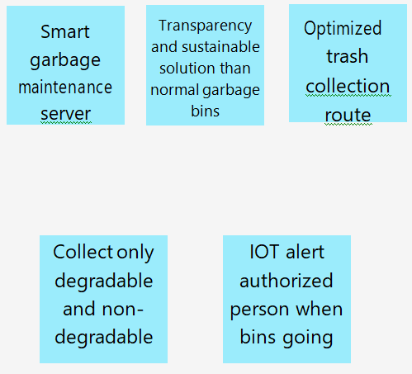

Fig 3.2.3 Group Ideas

## Prioritize

Your team should all be on the same page about what's important moving forward. Place your ideas on this grid to determine which ideas are important and which are feasible

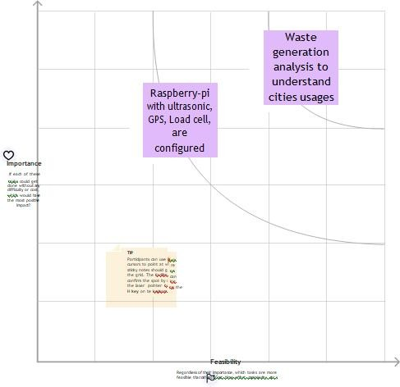

Fig 3.2.4 Prioritize

**After you collaborate**

1. Share the mural

Share a view link to the mural with stakeholders to keep them in the loop about the outcomes of the session.

1. Export the mural

Export a copy of the mural as a PNG or PDF to attach to emails, include in slides, or save in your drive

## PROPOSED SOLUTION

|  |  |  |
| --- | --- | --- |
| **S.No** | **Parameter** | **Description** |
| **1.** | **Problem Statement (Problem to be solved)** | The set and disposal of garbage waste is in unordered, ineffective way which leads to overfilling of bins, rotting garbage smell and more fuel utilization of  collecting trucks. |
| **2.** | **Idea / Solution description** | Using sensors, weighing machine; real timemonitoring the level of waste in bins. The information get shared with appropriateauthorities and fellow citizens through web application. |
| **3.** | **Novelty / Uniqueness** | Citizens & industries behavior during precise festival, events at different seasons are monitored and are predicted for garbage overflowing. Also to find the shortest path to reach the fate for trucks in basis of fuel and time consumption. |
| **4.** | **Social Impact / Customer**  **Satisfaction** | Informative, effective management of waste in bigcities reduces waste impacts over environment pollution. |
| **5.** | **Business Model (Revenue Model)** | * Eco-friendly. * Optimized route navigation system. * Reduce fuel consumption. * Alerts authority by real-time monitoring. * Promote 3R’s(Reduce, Reuse ,Recycle). |
| **6.** | **Scalability of the Solution** | * The need-driven waste collection eliminates unnecessary traffic blockage. * Generate important statistical data for monitoring for waste collection. * Recycling is promoted between residents,   results in clean &sustainable environment. |

Table 3.3.1 Proposed Solution

## PROBLEM SOLUTION FIT

**1. CUSTOMER**

**6. CUSTOMER**

**5. AVAILABLE**

**C**

which is the major

**2. JOBS-TO-BE-DONE /**

will be high

**9. PROBLEM ROOT**

**7.**

**Behaviour**

We need to monitoring the levels of bins and alerting the user to clean provide location ofthe bin, efficient service for

the expected results.

Lack of Public Awareness.Refusal to Learn About Compliance.

Insufficient Investment in Waste Management

Find the required sensor based on the requirements and get

The preliminary phase of this systemcomprises of proper disposal and anthology,

Rough action of user may damage the sensor The product may have short lifespan Network connection required properly Installation cost

Available solutions are use a reusable bottle/cupfor beverages on-the-go.

Use reusable grocery bags, and not just for groceries.

**8. CHANNELS of BEHAVIOUR**

Online:

* Use emails and articles instead of letters and magazines
* Create voluntary awareness in social
* Reduce recycle reuse
* Buy second handsand reduce goods
* Use biodegradablecovers
* Compost it

**4. EMOTIONS: BEFORE**

**/ AFTER**

Provide better environment for people live around bins.This technology can lead towards the development and adoption of a cleaner production, circular Economy and

effective waste

management.

Our solution is to provide a smart waste management system where sensors are fittedinsidethe dustbins which collect the waste in the locality and alert the respective people to collect and segregate the waste. The system also provides routeplanning for the

collection of the waste.

**10. YOUR SOLUTION**

**3. TRIGGERS**

* Landfill –growth
* Increases their profit.
* Incineration
* best way too trigger the customers to buy the product

Fig 3.4.1 Problem solution fit

12

# CHAPTER 4 REQUIREMENT ANALYSIS

* 1. **FUNCTIONAL REQUIREMENTS**

The functional requirements of smart waste management system are User registration, User conformation, GPS Access, Bin level Analysing, Transport Router.

Following are the functional requirements of the proposed solution.

|  |  |  |
| --- | --- | --- |
| **FR**  **No.** | **Functional Requirement (Epic)** | **Sub Requirement (Story / Sub-Task)** |
| FR-1 | **User Registration** | Registration through Gmail |
| FR-2 | **User Confirmation** | Confirmation via Email Confirmation via OTP |
| FR-3 | **GPS Access** | GPS admission to recognize the location |
| FR-4 | **Bin level Analysing** | Obtain the levels of Waste bins in a regular interval of time. |
| FR-5 | **Transport Router** | To make a efficient route for the collection of garbage in the region of a area. |

Table 4.1.1 Functional Requirements

# NON FUNCTIONAL REQUIREMENTS

The non functional requirements are Usability, Security **,**Reliability, Performance , Availability and Scalabilility

Following are the non-functional requirements of the proposed solution.

|  |  |  |
| --- | --- | --- |
| **FR**  **No.** | **Non- Functional Requirement** | **Description** |
| NFR-1 | **Usability** | A smart solution has been planned to make the waste sorting more simple and accurate, and look up the user experience, usability, and satisfaction. It aims to optimize ease of use while offering maximum  functionality. |
| NFR-2 | **Security** | The information of the users will be highly secured, the accounts are verified with Gmail. If the products are misplaced then the GPSdriven sensor gives an alert. |
| NFR-3 | **Reliability** | Operates in a defined environment without failure resulting in less manpower, emissions, fuel use and traffic congestion. |
| NFR-4 | **Performance** | The system will provide accurate reports, thus increasing the efficiency of the system. The real-time monitoring of the garbage levelwith the help of sensors and wireless communication will reduce the total number of trips required of Garbage collecting truck. This will reduce the total expenditure associated with the garbage collection. |
| NFR-5 | **Availability** | The smart waste bins are available in Convention centers, buildings, stadiums, and transportationfacilities and captures high-quality waste data and informs staff when it gets full. |
| NFR-6 | **Scalability** | A versatile scalable smart waste-bin system based on limited waste management could potentially lead to great improvements.Once these smart bins are implemented on a largescale by replacing the traditional bins, the waste can be quickly managed to its efficient level as it avoids unnecessary lumping of wastes on roadside. |

Table 4.2.1 Non-Functional Requirements

# CHAPTER 5 PROJECT DESIGN

* 1. **DATA FLOW DIAGRAM**

A Data Flow Diagram (DFD) is a traditional visual representation of the information flows within a system. A neat and clear DFD can depict the right amount of the system requirement graphically. It shows how data enters and leaves the system, what changes the information, and where data is stored.

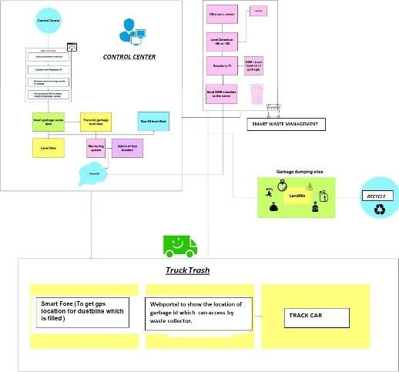

Figure 5.1.1 Data Flow Diagram

# SOLUTION AND TECHNICAL ARTCHITECTURE

The Deliverable shall include the architectural diagram as below and the information as per the Table1 & Table 2

**Example:** Order processing during pandemics for offline mode

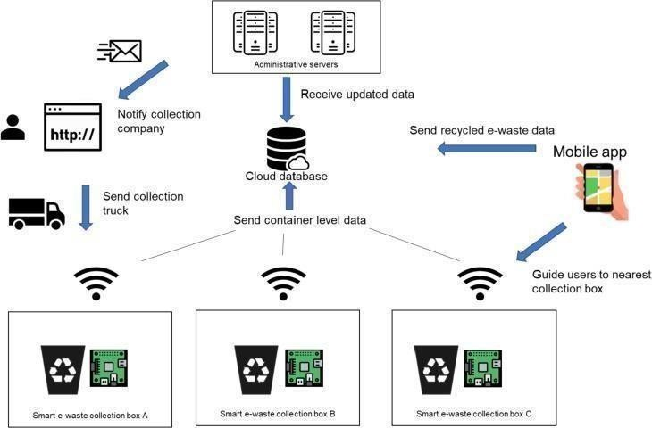

Figure 5.2.1 Solution & Technical Architecture

|  |  |  |  |
| --- | --- | --- | --- |
| **S.**  **No** | **Component** | **Description** | **Technology** |
| 1. | User Interface | IBM Watson IOT cloud platform | MQTT Protocol |
| 2. | Application Logic-1 | The bin waste data’s are collectedusing sensors | Python |
| 3. | Application Logic-2 | The collected data’s are monitoredusing IOT | IBM Watson STTservice |

16

|  |  |  |  |
| --- | --- | --- | --- |
| 4. | Application Logic-3 | Based on data’s the alerting message will send to the workersfor disposing the wastes. | IBM Watson Assistant |
| 5. | Database | * MySQL is a relational databasethat is based on a tabular design. * NoSQL is non-relational andhas adocument -based   design. | MySQL, NoSQL |
| 6. | Cloud Database | This module will receive real time status updates from all the garbage bins and continuously display it on web application and also push the notifications on client sides (Municipal Corporation,Garbage collector truck drivers etc.) mobile  application. | IBM DB2, IBM  Cloud |
| 7. | File Storage | Data storage makes it easy to back up files for safekeeping and quick recovery in the event of an unexpected computing crash or  cyber attack. | IBM Block storage orother storage device |

Table 5.2.1 Solution Architecture

|  |  |  |  |
| --- | --- | --- | --- |
| **S.**  **No** | **Characteris tics** | **Description** | **Technologies** |
| 1. | Open - Source Frameworks | Transport, treatment, and disposal of waste together with monitoring and regulation. | Python |
| 2. | Security Implementations | Fundamental component of data security that dictates who allowedto access and it use company information and resources. Firewalls use rule based access to control model with rules expressed  in an accesscontrol list. | Firewall |

17

|  |  |  |  |
| --- | --- | --- | --- |
| 3. | Scalable Architecture | Using smart waste bins, reduce the number of bins inside town and cities because that we capable to monitor the garbage 24/7.It will be more cost efficient and scalable  when we moves to smarter. | Technologyused |
| 4. | Availability | By developing & deploying resilient hardware and beautiful software we empower cities, businesses, and  countries to manage waste  smarter. | IOT, RFID |

Table 5.2.2 Technical Architecture

# USER STORIES

Use the below template to list all the user stories for the product.

|  |  |  |  |  |  |  |
| --- | --- | --- | --- | --- | --- | --- |
| **User Type** | **Functiona Requi rement (Epic)** | **l User Story Numb**  **er** | **User Story / Task** | **Acceptance criteria** | **Priority** | **Release** |
| Admin (who manage server) | Login | USN-1 | As an Admin, I gave userid and password for ever workers and manage them. | I can access my account / dashboard | Medium | Sprint-2 |
| Co Admin | Login | USN-2 | As a Co Admin, I'll manage garbage level monitor .if garbage get filling alert I will post location and garbage e idto trash  truck | I can receive confirmation email & click confirm | High | Sprint-1 |
| Truck Driver | Login | USN-3 | As Truck Driver, I'll follow the route send byCo Admin to reach the filled garbage | I can register& access the dashboard with Facebook Login | Medium | Sprint-2 |

|  |  |  |  |  |  |  |
| --- | --- | --- | --- | --- | --- | --- |
| Local | Login | USN-4 | As a Waste Collector, I'll collect all the trash  from | I can collect trash and | Medium | Sprint-2 |
| Garbage collector |  |  | garbage and load into garbage truck and send  them to landfill | pulled to truck and send off |  |  |
| Municipality | Login | USN-5 | As a Municipality, I'll checkthe process  are happening in disciplinemanner  without any issues. | I can manageall these process goinggood | High | Sprint-1 |

Table 5.3.1 User Stories

## CHAPTER 6

**PROJECT PLANNING AND SCHEDULING**

## SPRINT PLANNING AND ESTIMATION

|  |  |  |  |  |  |  |
| --- | --- | --- | --- | --- | --- | --- |
| **Sprint** | **Functional Requireme nt**  **(Epic)** | **User Story Number** | **User Story / Task** | **Story Points** | **Priority** | **Team Members** |
| Sprint-1 | Registration | USN-1 | As a user, I can register for  the application by entering my email | 2 | High | Ajmeer Kaja |
| Sprint-2 |  | USN-2 | As a user, I will receive confirmation email once I have registered for the application | 1 | High | Ansar |
| Sprint-3 |  | USN-3 | As a user, I can register for the application through Face book | 2 | Low | Arun Vinod |
| Sprint-4 | Dashboard | USN-4 | As a user, I can register for the application through Gmail | 2 | Medium | Nijaar Ahamad |

Table 6.1.1 Sprint Planning & Estimation

## Sprint Delivery scheduling

|  |  |  |  |  |  |  |
| --- | --- | --- | --- | --- | --- | --- |
| **Sprint** | **Total Story Points** | **Duration** | **SprintStart Date** | **Sprint End Date(Planned)** | **Story Points Completed (as on Planned End Date)** | **Sprint Release Date(Actual)** |
| Sprint-1 | 20 | 6 Days | 24 Oct 2022 | 29 Oct 2022 | 20 | 29 Oct 2022 |
| Sprint-2 | 20 | 6 Days | 31 Oct 2022 | 05 Nov 2022 | 30 | 30 OCT 2022 |
| Sprint-3 | 20 | 6 Days | 07 Nov 2022 | 12 Nov 2022 | 49 | 6 NOV 2022 |
| Sprint-4 | 20 | 6 Days | 14 Nov2022 | 19 Nov 2022 | 50 | 7 NOV 2022 |

Table 6.2.1 Sprint Delivery Scheduling

## REPORT FROM JIRA

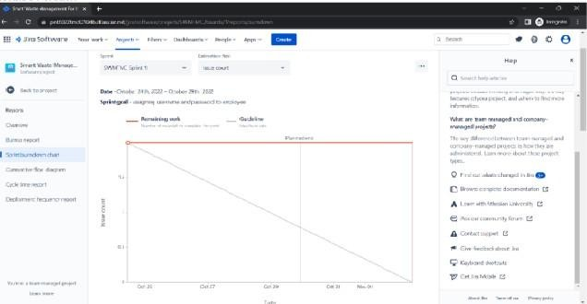

Figure 6.3.1 Reports From JIRA

## CHAPTER 7 CODING & SOLUTIONING

## FEATURE 1

## User Module

As members of an IoT ecosystem, users notify about their needs and desires, and provide feedback within a networked intelligence to mutually progress their individual ability to rule the actuators of the system at their service. User Device means a mobile or other handheld device.

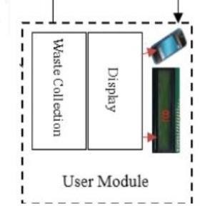

Fig 7.1.1.1 User Module

## Program:

**For Site Routes**

from flask import Blueprint

site = Blueprint('site', name )

@site.rout e('/')def

index():

return "<h1>Welcome to Our Waste Management System</h1>"@site.route('/health')

def health_check(): return "ok" **For Validate**

def validate(roles, data):if roles is None:

return True for role in roles:

print(role) print(data) print(role in data) if role not in data:

return False return True **Explanation**

In User Module, User can using a Blueprint to Access the Waste

Management to define the routes of the area. User will also check the health by defining this Module. For Validating the Route user can define the roles and data to check the given routes have garbage or not.

## FEATURE 2

* + 1. **Sensing Module**

Sensors and modules (having extra electronic circuitry along with sensor) are Electronic devices that detect and respond to some type of input from the physical environment..Sensors play a pivotal role in the internet of things (IoT). They make it possible to create an ecosystem for collecting and processing data about a specific environment so it can be monitored, managed and controlled more easily and efficiently.

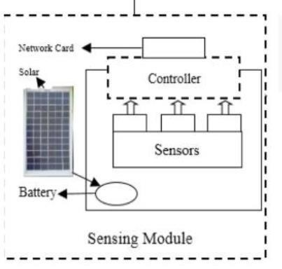

Fig 7.2.1.1 Sensing Module

## Program: For Scripts

"""${message}

24

Revision ID: ${up_revision} Revises: ${down_revision | comma,n}Create Date:

${create_date} """

from alembic import opimport sqlalchemy as sa

${imports if imports else ""} # revision identifiers, used by Alembic. revision =

${repr(up_revision)} down_revision

= ${repr(down_revision)} branch_labels =

${repr(branch_labels)} depends_on

= ${repr(depends_on)} def upgrade():

${upgrades if upgrades else "pass"}def downgrade():

${downgrades if downgrades else "pass"}

**For Environment Sensing**

from future import with_statementimport logging

from logging.config import fileConfig

from sqlalchemy import engine_from_configfrom sqlalchemy import pool

from flask import current_appfrom alembic import context

# this is the Alembic Config object, which provides

# access to the values within the .ini file in use. config = context.config

# Interpret the config file for Python

logging.# This line sets up loggers basically. fileConfig(config.config_file_name) logger = logging.getLogger('alembic.env')# add your model's MetaData object here # for 'autogenerate' support

# from myapp import mymodel # target_metadata = mymodel.Base.metadata config.set_main_option( 'sqlalchemy.url',

str(current_app.extensions['migrate'].db.engine.url).replace('%', '%%')) target_metadata =

current_app.extensions['migrate'].db.metadata# other values from the config, defined by the needs of env.py,

# can be acquired:

# my_important_option = config.get_main_option("my_important_option")# ... etc. def run_migrations_offline():

"""Run migrations in 'offline' mode.

This configures the context with just a URL and not an Engine, though an Engine is acceptablehere as well. By skipping the Engine creation

we don't even need a DBAPI to be available.

Calls to context.execute() here emit the given string to the script output.

"""

url = config.get_main_option("sqlalchemy.url") context.configure(

url=url, target_metadata=target_metadata, literal_binds=True

)

with context.begin_transaction():context.run_migrations() def run_migrations_online():

"""Run migrations in 'online' mode. In this scenario we need to create an

Engineand associate a connection with the context."""

# this callback is used to prevent an auto-migration from being

27

generated# when there are no changes to the schema

# reference: <http://alembic.zzzcomputing.com/en/latest/cookbook.html> def process_revision_directives(context, revision, directives):

if getattr(config.cmd_opts, 'autogenerate', False): script = directives[0]

if script.upgrade_ops.is_empty(): directives[:] = []

logger.info('No changes in schema detected.')connectable = engine_from_config( config.get_section(config.config_ini_section), prefix='sqlalchemy.', poolclass=pool.NullPool,

)

with connectable.connect() as connection:context.configure(

connection=connection, target_metadata=target_metadata, process_revision_directives=process_revision_directives,

**current_app.extensions['migrate'].configure_args

)

with context.begin_transaction(): context.run_migrations()

if

context.is_offline_mode ():

run_migrations_offline(

)

else: run_migrations_online()

## DATABASE SCHEMA

**Step 1:** Create A Cloundant DB With Your Credentials

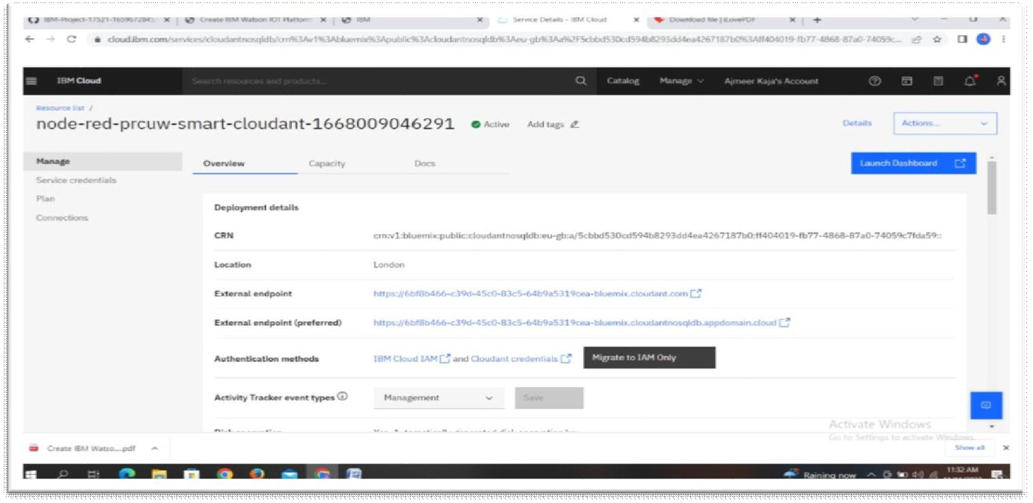

Fig 7.3.1 Cloudant DB

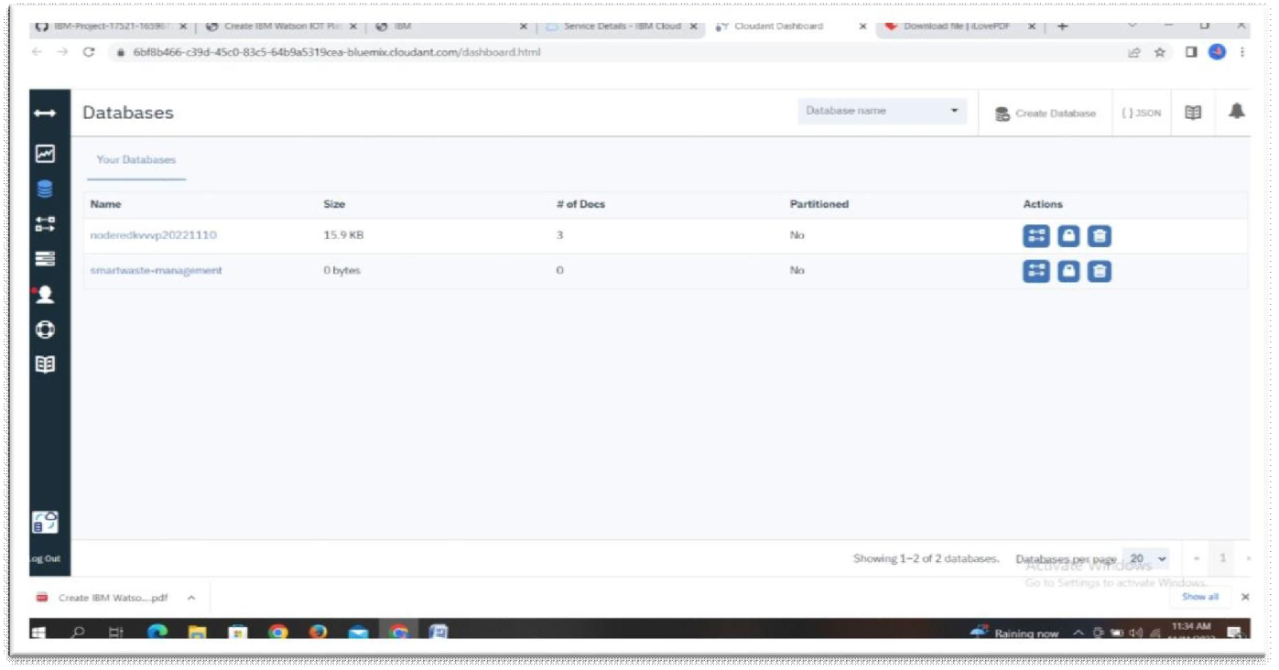**Step 2:** Then Launch Dashboard To see your Database Page

Fig 7.3.2 DB Creation

**Step 3:** Then Create Your Database for your Project.

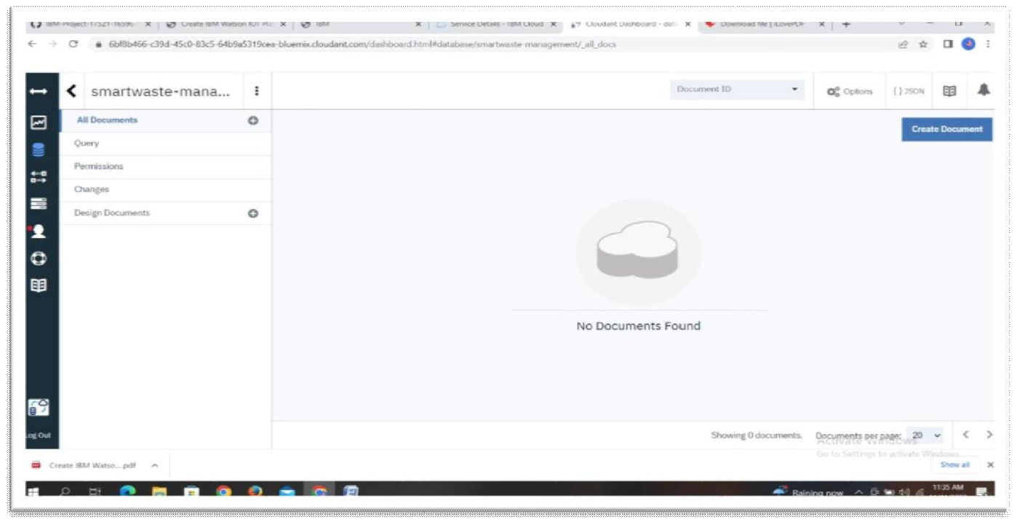

Fig 7.3.3 Smart waste Management DB

## CHAPTER 8 TESTING

## TEST CASES

The purpose of testing is to discover errors. Testing is the process of trying to discover every conceivable fault or weakness in a work product. It provides a way to check the functionality of components, sub-assemblies, assemblies and/or a finished product. It is the process of exercising software with the intent of ensuring that the Software system meets its requirements and user exceptions and does not fail in an unacceptable manner. There are various types of test. Each test type addresses a specific testing requirement.

## USER ACCEPTANCE TESTING

User Acceptance Testing (UAT) is a type of testing performed by the end user or the client to verify/understand the software system before moving the software application to the invention environment. UAT is done in the final phase of testing after functional, integration and system testing is done.

User Acceptance Testing is a critical phase of any project and requires significant participation by the end user. It also ensures that the system meets the functional requirements

**Test Results:** All the test cases mentioned above are passed approximately with somedefects encountered.

## CHAPTER 9 RESULTS

**9.1 PERFORMANCE METRICES**

Performance metrics are defined as figures and data representative of an organization’s actions, abilities, and overall quality. There are many different forms of performance metrics, including sales, profit, return on investment, customer happiness, customer reviews, personal reviews, overall quality, and reputation in a marketplace. Performance metrics can vary considerably when viewed through different industries.

Performance metrics are integral to an organization's success. It's important thatorganizations select their chief performance metrics and focus on these areas because these metrics help guide and gauge an organization’s success. Key success factors are only useful if they are acknowledged and tracked. Business measurements must also be carefully managed to make sure that they give right answers, and that the right questions are being asked.

|  |  |  |
| --- | --- | --- |
| **S.No.** | **Parameter** | **Values** |
| 1. | Model Summary | These may be determined by organizational policy, adherence to a published standard or an analysis of the requirements based on use,  ability to measure, or more. |
| 2. | Accuracy | Training Accu–racy somedefects Encountered  Validation Accuracy Suc–cessfully Passed |

Table 9.1.1 Performance metrics

## CHAPTER 10 ADVANTAGES & DISADVANTAGES

**ADVANTAGES**

* + - Improve Productivity and Performance.
    - Increase Profitability.
    - Boost Sustainability.
    - Superior Customer Engagement.
    - Become a Smart City.
    - Enhance Safety.

**DISADVANTAGES**

* + - These results into high initial cost due to expensive smart dustbins compare to other methods.
    - Sensor nodes used in the dustbins have limited memory size.
    - Wireless technologies used in the system such as zigbee and wifi have shorter range and lower data speed.
    - It requires a well structured hardware.
    - The onetime cost of installation will be higher than the present technique.

## CHAPTER 11 CONCLUSION

Project work is the implementation of smart waste management system using ultrasonic sensor, arduino and Wi-Fi modules such as sensing modules, user modules. This system assures the cleaning of dustbins soon when the garbage level reaches its maximum. This reduces the total number of trips of garbage collection vehicle and hence reduces the overall expenditure associated with the garbage collection. It ultimately helps to keep cleanliness in the society. Therefore, the smart garbage management system makes the garbage collection more efficient. Smartdustbin helps us to reduce pollution. This project ensures waste collection on time which in turn ensures less contamination of environment, no spread of disease and a cleaner surrounding.

## CHAPTER 12 FUTURE SCOPE

The future of Waste management starts and proceeds with technological adjustments. Like every other industry, to proceed, the waste management industry needs to become digitized and data-driven to advance its work field. The future is smart and competitive! Especially for businesses, they are required to be one step ahead of their competitors. When smart waste management solutions are applied over time, the data is collected. These data in hand sensors can be used to identify fill patterns, optimize driver routes and schedules, and reduce operational costs. These sensors’ cost is steadily decreasing, making smart bins more feasible to implement and more attractive to companies or city leaders. When we say that the future is smart, it also means that it is practical. The selection of the containers minimizes the need fortrash collection crews. The amount of labor and time spent on collection processes is minimized, and ultimately it’s profitable. In addition to hardware, the time spent is reduced for management and reduced by using easy to use compact and comprehensive platforms and mobile apps for both ends of the waste management processes.

## CHAPTER 13 APPENDIX

## Source code

from flask import Blueprint, jsonify, request, abort, Response, send_file

from app.models import Basket, User, Waste, Vehicle, Employee, commit, Area, SoftwareVersion,

BasketType from

app.validate import validate import json

from datetime import datetimefrom io import BytesIO

api = Blueprint('api', name , url_prefix='/api')

@api.rout e('/')def

index():

return jsonify({"message": "the api is working"}) @api.route('baskets'

) def get_baskets():

baskets = Basket.query.all()

baskets_list = [basket.format() for basket in baskets] return jsonify({

"baskets": baskets_list, "total_baskets": len(baskets_list)

})

@api.route('baskets/<int:basket_id>'

) def get_basket(basket_id): basket = Basket.query.get(basket_id)return jsonify({

@api.route('baskets/<int:basket_id>/wastes ') def get_wastes_of_basket(basket_id): basket = Basket.query.get(basket_id)

wastes = [waste.format() for waste in basket.wastes] total_size = 0.0

for waste in wastes:

total_size = total_size + waste['size'] print(type(waste['size']), waste['size']) print(total_size) print(total_size)return jsonify({ "basket_id": basket.id,

"total_size": total_size, "wastes": wastes

})

@api.route('baskets', methods=['POST'])def add_new_basket(): data = request.json

roles = ['longitude', 'latitude', 'area_code'] abort(400) if not validate(roles, data) else Nonelongitude = data['longitude']

latitude = data['latitude']

area_code = data['area_code']type_id = data['type'] area = Area.query.get(area_code)if not area:

abort(422)

basket_type = BasketType.query.get(type_id)if not basket_type:

abort(422)

basket = Basket(longitude=longitude, latitude=latitude, area=area, basketType=basket_type).save()

return jsonify({ "success": True,

@api.route('baskets/<int:basket_id>', methods=['DELETE'])def delete_baskets(basket_id):

basket = Basket.query.get(basket_id)

basket = basket.delete() if basket else basket return jsonify({

'success': bool(basket)

})

@api.route('baskets', methods=['PATCH'])def update_all_baskets():

data = request.json

software_version = data['software_version']

baskets = Basket.query.update({Basket.software_version: software_version}) commit()

return jsonify({ "baskets_update": baskets

})

@api.route('baskets/<int:basket_id>', methods=['PATCH']) def update_the_basket(basket_id):

data = request.json basket_level = data['level'] if basket_level is None:

abort(400) try:

basket = Basket.query.get(basket_id) basket.wastes_height = basket_level

basket.save()except: abort(422)

return jsonify({ "success": True,

})

@api.route('areas')def get_areas():

areas = Area.query.all()

areas_list = [area.format() for area in areas] return jsonify({

38

"total_areas": len(areas_list), "areas": areas_list

})

@api.route('areas/<int:area_code>') def get_area(area_code):

area = Area.query.get(area_code) return jsonify({

"area": area.format()

})

@api.route('areas/<int:area_code>/baskets') def get_basket_belong_to_area(area_code): baskets = Area.query.get(area_code).baskets

baskets_list = [basket.format() for basket in baskets] return jsonify({

"total_baskets": len(baskets_list), "baskets": baskets_list

})

@api.route('areas/<int:area_code>/users')def get_user_belong_to_area(area_code):

users = Area.query.get(area_code).users users_list = [user.format() for user in users] return jsonify({

"total_users": len(users_list), "users": users_list

})

@api.route('areas', methods=['POST'])def insert_new_area():

data = request.json

roles = ['area_code', 'area_name', 'area_size', 'longitude', 'latitude', 'city'] if not validate(roles, data):

abort(422)

code = data['area_code'] name = data['area_name'] size = data['area_size'] longitude = data['longitude'] latitude = data['latitude']

city = data['city']

area = Area(code=code, name=name, size=size, longitude=longitude, latitude=latitude, city=city)

area.save(True) return jsonify({

"success": True, "area": area.format()

})

@api.route('vehicles') def get_vehicles():

vehicles = Vehicle.query.all()

vehicles_list = [vehicle.format() for vehicle in vehicles] return jsonify({

"vehicles": vehicles_list

})

@api.route('vehicles/<int:vehicle_plate_no>'

) def get_vehicle(vehicle_plate_no):

vehicle = Vehicle.query.get(vehicle_plate_no) return jsonify({

"vehicle": vehicle.format()

})

@api.route('vehicles', methods=['POST'])def create_vehicle():

data = request.json

roles = ['plate_number', 'container_size', 'tank_size', 'employee_ssn'] if not validate(roles, data):

abort(400)

plate_number = data['plate_number'] container_size = data['container_size'] tank_size = data['tank_size'] employee_ssn = data['employee_ssn']

driver = Employee.query.get(employee_ssn)

if not driver:

abort(404) # try:

vehicle = Vehicle(plate_number=plate_number, container_size=container_size, tank_size=tank_size, driver=driver)

vehicle.save(True) return jsonify({ "success": True,

"vehicle": [vehicle.format()]

})

# except:

#abort(422)

@api.route('employees') def get_employees():

employees = Employee.query.all()

employees_list = [employee.format() for employee in employees] return jsonify({

"total_employees": len(employees_list), "employees": employees_list

})

@api.route('employees/<int:employee_ssn>'

) def get_employee(employee_ssn):

employee = Employee.query.get(employee_ssn) return jsonify({

"employee": employee.format()

})

@api.route("employees", methods=['POST'])def create_new_employee(): data = request.json

ssn = data['ssn']

full_name = data['full_name']

user_name = data['user_name'] password = data['password'] date_of_birth = data['data_of_birth']

phone = data['phone']

print(ssn)

if not ssn or not full_name or not user_name or not password or not date_of_birth or not phone:

abort(400)

employee = Employee(SSN=ssn, full_name=full_name, user_name=user_name, password=password, DOB=date_of_birth,

phone=phone).save(True)return jsonify({

"success": True,

# "employee": [employee.format()]

})

@api.route("employees", methods=['PATCH'])def update_supervisor():

# TODO update the supervisor for all employee return '’

@api.route('employees/<int:employee_ssn>', methods=['DELETE']) def delete_employee(employee_ssn):

employee = Employee.query.get(employee_ssn) if employee is None:

abort(404)

employee.update()return jsonify({ "success": True

})

@api.route('users')def get_all_users(): users = User.query.all()

users_list = [user.format() for user in users]return jsonify({"user": users_list})

@api.route('users', methods=['POST'])def create_new_user():

data = request.json

user_name = data['user_name']first_name = data['first_name']last_name = data['last_name'] email = data['email']

password = data['password']gender = data['gender']

area = data['area_code'] area = Area.query.get(area)if not area:

abort(404)

roles = ['user_name', 'first_name', 'last_name', 'email', 'password', 'gender']

abort(400)

if not validate(roles, data) else Nonetry:

user = User(user_name=user_name, first_name=first_name, last_name=last_name, email=email, password=password, gender=gender, area=area).save(True)return

jsonify({

"success": True, 'user':

user.format()

})

except:

abort(422)

@api.route('wastes') def get_waste():

data = request.args

basket_id = data.get('basket_id', 0, int)

wastes = Waste.query.all() if not basket_id else Waste.query.filter_by(basket_id=basket_id).all()

wastes_list = [waste.format() for waste in wastes]total_size = 0 for waste in wastes_list: total_size += +waste['size']

return jsonify({ "total_wastes_size": total_size,"wastes": wastes_list,

})

@api.route('wastes', methods=['POST'])def insert_new_waste(): data = request.json

basket = Basket.query.get(data['basket_id'])

is_full = basket.set_wastes_height(data['waste_height'])if is_full: abort(422)

waste_size = basket.get_waste_volume(data['waste_height'])

waste = Waste(size=waste_size, type='bio', DOC=datetime.utcnow(), basket=basket).save()

return jsonify({

"basket_level": basket.get_basket_level(),"waste": waste.format()

})

@api.route('wastes', methods=['DELETE'])def delete_waste(): # waste = Waste.query.filter_by(type='bio').delete()# db.session.commit()

waste = Waste.query.all()print(waste)

return ''

@api.route('test', methods=['POST', "GET"])def test(): data = request.jsonreturn jsonify({

"value": data['value']

})

@api.route("/baskets_types") def get_basket_type(): types_of_baskets = BasketType.query.all()

type_list = [type_of_basket.format() for type_of_basket in types_of_baskets] return jsonify({

"types": type_list

})

@api.route("/baskets_types", methods=["POST"])def create_basket_type(): data = request.json length = data["length"]height = data["height"]width = data["width"]

micro_controller = data["micro_controller"]roles = ['length', 'height', 'width']

abort(400) if not validate(roles, data) else Nonetry:

basket_type = BasketType(length=length, height=height, width=width,

micro_controller=micro_controller).save() return jsonify({

"success": True,

'Type': basket_type.format()

})

except:

abort(422) @api.route('/baskets/<int:basket_id>/versio ns') def get_basket_software_version(basket_id):

basket = Basket.query.get(basket_id) software_versions =

SoftwareVersion.query.filter_by(basket_id=basket_id).order_by(SoftwareVersion.dat e.desc()).all()

list_software_version = [] status = 'update'

for software_version in software_versions:

if software_version.version == basket.software_version:status

= 'rollback' list_software_version.append(software_version.format('current')) continue list_software_version.append(software_version.format(status))return jsonify({

"software_versions": list_software_version, "current_version": basket.software_version

})

@api.route("/software_versions/<string:version>"

) def get_file(version):

software = SoftwareVersion.query.get(version) file_name = "{}.bin".format(software.version)

return send_file(BytesIO(software.file), attachment_filename=file_name, as_attachment=True)

@api.route("/software_versions", methods=["POST"])def post_file():

file = request.files['file']

update_type = request.form.get("update_type", None)

basket_id = request.form.get("basket_id", None) basket = Basket.query.get(basket_id)

last_version = SoftwareVersion.query.filter_by(basket_id=basket_id).order_by(SoftwareVersion.dat e.desc()).first()

if last_version:major, minor, patch = last_version.version.split(".")if update_type == "patch": patch = int(patch) + 1

*elif update_type == "minor*": minor = int(minor) +

1patch = 0

elif update_type == "major": major = int(major) + 1 patch = 0

minor = 0 else:

abort(422) print(last_version.version.split())

version = "{}.{}.{}".format(major, minor, patch) else:

version = "0.1.0" print(version) print(last_version)

software_version = SoftwareVersion(version=version, file=file.read(), basket=basket)

software_version.save(True) return jsonify({

"success": True,

"version": software_version.version

}), 201

## Github Link

https://github.com/IBM-EPBL/IBM-Project-47741-1660801872

## Demonstration Link

https://drive.google.com/file/d/1g6p7eg6HIOERET9dG5-nUAwKeOuY97G3/view?usp=sharing

46